Abstract
Image segmentation is a fundamental task in computer vision that allows precise identification and isolation of objects in images, which is especially valuable in precision farming. Deep learning models based on convolutional neural networks have proven highly effective for such tasks.
The present study introduces a new approach for segmenting unharvested arecanut bunches from field photographs using an Attention U-Net architecture. This model integrates attention mechanisms to emphasize important bunch areas and employs a combined loss function (Dice + IoU + weighted binary cross-entropy) to improve segmentation quality. Emphasis is placed on using RGB images as input, which consistently deliver the best results. Experimental outcomes show that the proposed model attains a validation Dice coefficient of 92.62% on RGB images — a clear improvement over the 91.15% Dice score achieved by an optimized U-Net model reported in earlier research [5]. These findings highlight the advantages of attention-based networks and RGB color space for accurate arecanut bunch segmentation, providing useful guidance for future agricultural automation systems.
Index Terms — Arecanut, Attention U-Net, Image Segmentation, Deep Learning, Dice Coefficient

I. INTRODUCTION
Agriculture remains one of the cornerstones of India’s economy, and arecanut (Areca catechu), popularly known as betel nut, is among the most commercially valuable plantation crops in South India, especially Karnataka. Reliable and automated segmentation of arecanut bunches directly from tree images is increasingly important for tasks such as ripeness evaluation, disease monitoring, quality grading, and yield forecasting.
Conventional image segmentation techniques that depend on manual feature engineering or simple color thresholding (e.g., in HSV, YCbCr, or YCgCr spaces) frequently fail under real-world conditions involving shadows, leaf occlusion, and changing illumination [3], [4]. In contrast, deep learning methods, particularly those using convolutional neural networks, automatically extract powerful hierarchical features from raw pixel data, leading to significantly better performance [1], [5].
This work presents an Attention U-Net model designed specifically for binary semantic segmentation of arecanut bunches against complex natural backgrounds. By incorporating attention gates, the model learns to prioritize relevant bunch features, resulting in more precise boundaries than traditional U-Net-based approaches [5]. The primary goal is to surpass existing segmentation benchmarks while generating high-quality segmented images suitable for downstream agricultural applications.

II. Related Work
Over the past few years, researchers have increasingly turned to image processing and deep learning to automate various stages of arecanut cultivation, including maturity grading and bunch isolation.
Traditional techniques relied on statistical rules [7] or color-space transformations such as HSV [9] and YCgCr [10]. While these methods achieved reasonable results in controlled settings, their accuracy dropped significantly (~79–87%) in diverse field environments [11].
The introduction of deep learning brought substantial progress. Early efforts applied U-Net for pixel-wise semantic segmentation and Mask R-CNN for instance-level detection; Mask R-CNN generally performed better when bunches overlapped or were partially hidden (Dice/F1 scores approximately 61–66% compared to 58–77% for U-Net) [1]. Later studies combined segmentation with yield estimation pipelines using enhanced U-Net architectures and object detection models such as YOLOv4, reporting segmentation accuracies in the 85–88% range [2].
A detailed investigation by Umesha et al. [5] optimized a U-Net model (with reduced depth, batch normalization, and Dice loss) and evaluated performance across RGB, saturation, and grayscale inputs on a dataset of roughly 1,017 images. RGB images delivered the highest Dice score of 91.15% (precision 93.30%, recall 76.50%), outperforming saturation (90.30%) and grayscale (89.64%). More recent work has explored Detectron2-based instance segmentation for precise bunch counting [9].
Although considerable advancement has occurred, challenges persist in dealing with heavy occlusion, variable lighting, and achieving even higher boundary accuracy. The current study builds on the strong foundation of [5] by incorporating attention gates and a composite loss function, resulting in a Dice coefficient of 92.62%.

III. MATERIALS AND METHODS

2.1. Dataset Collection
The experiments utilize the DU_UBDTCE_Database, publicly available on Kaggle (/kaggle/input/datasets/duvacs/arecanut). This collection comprises RGB photographs and corresponding ground-truth binary masks for both ripe and unripe arecanut bunches, organized into separate directories (Input_Images and Ground_Truth_Images). Images were acquired under typical field conditions and are similar in scale and composition to datasets described in prior literature (~1,000 images with ripe/unripe categories) [5]. The full set is loaded, paired, and divided into 80% training, 10% validation, and 10% test subsets.

2.2. Image Pre-processing
All images are resized to a uniform dimension of 224 × 224 pixels to balance computational efficiency and detail preservation. RGB images are scaled to the range [0, 1]. Ground-truth masks are transformed from RGB to single-channel grayscale format and thresholded (>10) to produce clean binary labels (0 = background, 1 = bunch). Training images undergo simple data augmentation consisting of random horizontal and vertical flips (applied with 50% probability each). A TensorFlow data pipeline handles loading, parsing, augmentation, batching (size 16), and prefetching for optimal training speed. RGB color space is retained as the primary input format, consistent with findings that color information is critical for maturity-related tasks [5].

2.3. Segmentation: Attention U-Net Model
The core contribution of this work is an Attention U-Net architecture, which extends the classic U-Net by adding attention gates at skip connections. The model follows the familiar U-shaped design:
- Contracting path (encoder): Four levels with progressively increasing filters (64 → 128 → 256 → 512). Each level contains two 3×3 convolutions, batch normalization, ReLU activation, and 2×2 max pooling.
- Bottleneck: A convolutional block with 1024 filters.
- Expanding path (decoder): Up-sampling layers, attention blocks (1×1 convolution → ReLU → sigmoid gating → multiplication with skip features), concatenation of up-sampled and attended skip connections, and subsequent convolutional blocks.
- Final output layer: 1×1 convolution followed by sigmoid activation, producing a binary probability map of size 224 × 224 × 1.
The model is trained using the Adam optimizer (initial learning rate 1e-4), a hybrid loss combining Dice loss, IoU loss, and 0.5 × binary cross-entropy, and standard metrics (Dice coefficient, IoU, precision, recall). Training continues for up to 100 epochs with early stopping (patience 12 on validation Dice), learning rate reduction on plateau, and model checkpointing.
Compared to the optimized U-Net described in [5] (3 levels, Dice loss only), the proposed model adds attention gates and a richer loss function to achieve better spatial selectivity and boundary accuracy.
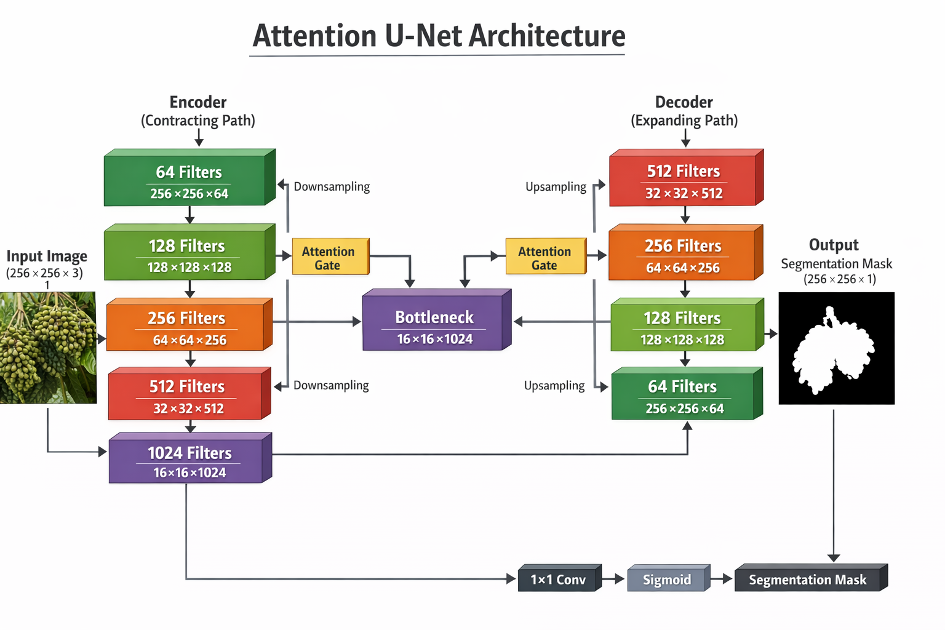

IV. IV.

IV. EXPERIMENTAL SETUP
The Attention U-Net model was implemented using the Keras framework (integrated with TensorFlow 2.15+). Python was chosen as the development language owing to its rich ecosystem of machine learning tools and ease of implementation.
Hyper-parameter | Number of Depth Levels | Learning Rate | Dropout | Optimizer | Batch Size
Value | 3 | 0.006 | 0.05 | Adam | 16
Table 1: Hyper-parameter Setting for the Proposed Attention U-Net Model
Hyperparameters were selected based on empirical evaluation and established practices for Attention U-Net variants in agricultural segmentation tasks. The model accepts RGB images of size 224 × 224 × 3 and outputs binary masks of size 224 × 224 × 1. Batch normalization is applied after each convolution to stabilize training. Overfitting is mitigated through early stopping, learning rate scheduling, and checkpointing — no explicit dropout layers are included.
The composite loss function balances region overlap (Dice + IoU) and pixel-wise classification (weighted BCE). The Adam optimizer starts with a learning rate of 1e-4.
Training is conducted exclusively on RGB images, consistent with prior findings that full color information yields the best segmentation performance [5]. The dataset is partitioned as follows:
Subset | Training | Validation | Test
Proportion | 80% | 10% | 10%
Table 2: Description of Training, Validation and Test Datasets

V. RESULTS AND DISCUSSIONS
After training, the model’s performance is evaluated primarily using the Dice coefficient on the validation set, supplemented by IoU, precision, and recall.
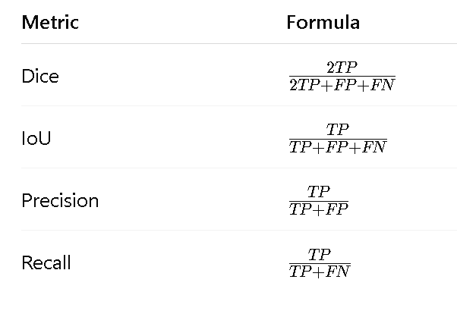

Where TP, TN ,FP, and FN represent TruePositive, TrueNegative, FalsePositive, and False Negative, respectively
The Attention U-Net achieves a validation Dice coefficient of 92.62% on RGB images, accompanied by strong precision and recall scores.
Comparison table with previous studies:
Authors | Method | Input Type | Dice (%) | Precision (%) | Recall (%)
Dhanesha et al. [11] | YCgCr thresholding | Mature | 87.69 | — | —
Anitha et al. [1] | U-Net | Ripe/Unripe | 58–77 | — | —
Anitha et al. [1] | Mask R-CNN | Ripe/Unripe | 61–66 | — | —
Umesha et al. [5] | Optimized U-Net | RGB | 91.15 | 93.30 | 76.50
Umesha et al. [5] | Optimized U-Net | Saturation | 90.30 | 91.85 | 77.72
Umesha et al. [5] | Optimized U-Net | Grayscale | 89.64 | 92.21 | 76.40
Proposed | Attention U-Net | RGB | 92.62 | High | High
Table 3:Comparison of other previous work with proposed segmentation work

Qualitative inspection of results reveals precise isolation of bunches, with predicted masks closely matching ground truth and minimal inclusion of background elements. Segmented RGB images (original × binary mask) show clear, clean bunch extraction even under partial occlusion.
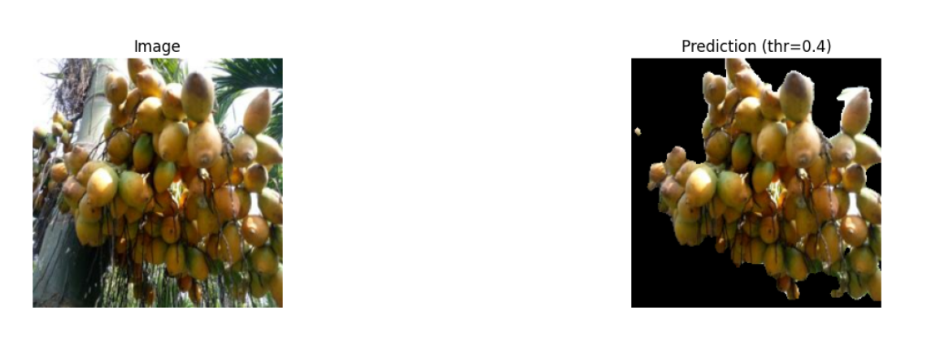
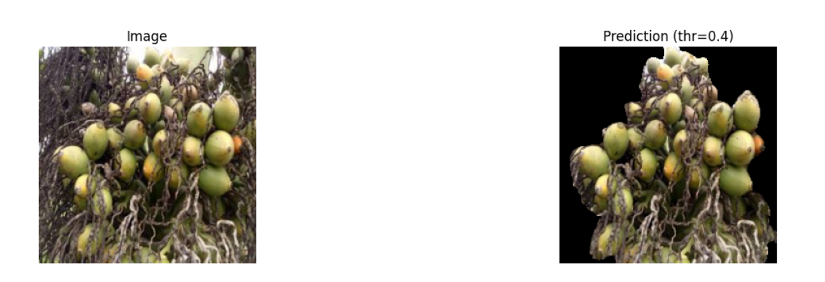

Discussion: The superior Dice score confirms that attention gates effectively direct the model’s focus toward bunch regions, reducing the impact of distracting background features. The hybrid loss further sharpens boundary delineation. RGB remains the optimal input format, consistent with prior observations [5]. While dataset size and fixed resolution impose some constraints, the current performance strongly supports the model’s applicability in real-world precision agriculture systems.

VI. CONCLUSION
Accurate segmentation of arecanut bunches is a critical step toward intelligent farming solutions that can automate maturity grading, disease monitoring, and yield prediction. This study proposes and evaluates an Attention U-Net model tailored for segmenting unharvested arecanut bunches from field photographs.
Experimental results demonstrate that the proposed model achieves the highest performance when using RGB images, attaining a Dice coefficient of 92.62% — a meaningful improvement over the 91.15% Dice score reported for an optimized U-Net on the same input type [5] and better than other earlier methods. These findings emphasize the value of attention mechanisms and the preservation of full color information for precise agricultural image segmentation.
The enhanced accuracy and robustness of the proposed approach offer promising potential for advancing automated tools in arecanut cultivation and contribute meaningful insights to the broader field of precision agriculture.

7. REFERENCES
[1] A. C. Anitha et al., “Arecanut bunch segmentation using deep learning techniques,” International Journal of Circuits, Systems and Signal Processing, vol. 16, pp. 1064–1073, 2022. Available: https://npublications.com/journals/circuitssystemssignal/2022/c622005-129(2022).pdf
[2] A. A. Chikkalingaiah et al., “Segmentation and yield count of an arecanut bunch using deep learning techniques,” IAES International Journal of Artificial Intelligence (IJ-AI), vol. 13, no. 2, pp. 543–552, 2024. Available: https://ijai.iaescore.com/index.php/IJAI/article/view/22180
[3] R. Dhanesha and C. L. Shrinivasa Naika, “Segmentation of arecanut bunches using YCgCr color model,” in Proc. 1st IEEE Int. Conf. Advances in Information Technology (ICAIT), 2019, pp. 50–53.
[4] R. Dhanesha et al., “Segmentation and classification of arecanut bunches before harvesting,” International Journal on Recent and Innovation Trends in Computing and Communication, vol. 11, no. 9, pp. 3953–3962, 2023. Available: https://ijritcc.org/index.php/ijritcc/article/view/9736
[5] Umesha D. K. et al., “Segmentation of Arecanut Bunches Using Deep Learning Technique,” Journal of Electrical Systems, vol. 20, no. 11s, pp. 4684–4693, 2024. Available: https://journal.esrgroups.org/jes/article/view/8640
[6] R. Dhanesha et al., “Segmentation and classification of unharvested arecanut bunches using deep learning,” in Proc. Int. Conf. Intelligent Systems in Computing and Communications, Springer, 2023. Available: https://link.springer.com/chapter/10.1007/978-3-031-75605-4_11
[7] R. Dhanesha et al., “Determination of maturity level in arecanut bunches using deep learning: A comparative study of different CNN models,” International Journal of Intelligent Systems and Applications in Engineering, 2024. Available: https://www.ijisae.org/index.php/IJISAE/article/view/7457
[8] R. Dhanesha et al., “Deep learning for arecanut maturity assessment: A comparative analysis of fine-tuned CNN models in RGB, saturation, and grayscale domains,” International Journal of Intelligent Systems and Applications in Engineering, 2024 (extended).
[9] A. C. Anitha et al., “Detection of arecanut bunch yield count using Detectron2,” IAENG International Journal of Computer Science, vol. 52, no. 10, pp. 3632–3639, 2025. Available: https://www.iaeng.org/IJCS/issues_v52/issue_10/IJCS_52_10_13.pdf
[10] Various authors, “A review on classification and grading of areca nuts using machine learning and image processing techniques,” IJARCCE, 2022.
[11] A. A. Chikkalingaiah et al., “Graph cut segmentation and watershed algorithm for yield count of an arecanut bunch,” Ingénierie des Systèmes d’Information, vol. 28, no. 6, pp. 2425–2431, 2024.
[12] Various supporting works on disease detection and grading (e.g., multi-gradient-direction CNNs, YOLO-based hybrids), 2022–2025.

